FM 104.1 WFTB-LP - Nashville, Tennessee
Filetype: MP3 (192kbps preferred)
Filenames: WFTB-AM.mp3
Starting with AM only, should be written/designed to play AM and PM slots, so limit AM or PM specific language.
Length: ~35-40 seconds
Intro: "Now your weather from WFTB 104.1 FM Nashville Gospel Radio.... I'm...."
Today WINTER STORM WARNING IN EFFECT STARTING IN THE EVENING Heavy snow expected. Total snow accumulations between 1 and 3 inches. HIGH 36 LO 21
TOMORROW AM SNOW SHOWERS HI 27 LOW 11
THURSDAY PARTLY CLOUDY HIGH 24 LOW 9
FRIDAY PARTLY CLOUDY AND WARMER HI 45 LOW 25
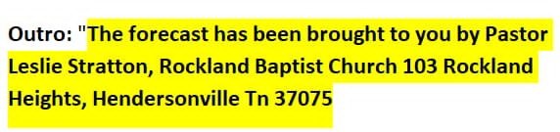
Outro: Place forecast in the WFTB directory on our server.
Updated November 26, 2024 by JC

